Concept: Company Management System (CMS)
Concept: Company Management System (CMS)
A system that contains all data/processes and reports of an employee on the company

Project Group Members
Name | Student ID | Responsibilities
Amon Oswald Hackl | 673040671-2 | Planning /register /contact_list /user_data
Premiga Pengtap | 673040672-0 | GUI /Login_page /Main_page /helpdesk
Yu Thandar Kyaw | 673040470-2 | UX/UI /report /error /Main_page /approved

Motivations and Problem Statements
What real-world problem
- There are many difficulties in a company in managing employee data, approvals, and requests. Most of the traditional methods, such as spreadsheets, cause delays and security risks.

Who experiences it and how
- HR departments, managers, employees, companies, and every company that doesn't have a time-saving and easy-to-use Company Management system. They don't have enough employee data, and employees have difficulties checking approvals, reports, and help desk requests in one place.

Why is it important to solve
- It reduces a lot of tasks, helps company data be more consistent, and improves the security of each position's control.

Why it's worth solving — (2)genuine problems
1) Toyota Production Crisis (2009)
- Because the company became bigger, they faced control inefficiency in the management system. It shows it can cause slow decision-making and also loss of productivity.
2) Blockbuster depended only on physical stores while Netflix launched online streaming. It shows the failure to adopt new technology.

Objectives
- Develop login and register system to ensure security for employees and managers.
- Implement employee data and update user data.
- Create an approval system in which managers or higher positions can approve or deny user requests digitally.
- Develop a helpdesk system in which employees can submit and report their problems
- Create a log-out feature to have strong security and user control.

Target Group
- Employees (submitting requests, view data)
- HR officer / managers and higher(manage employees record and control approval)

Their need and pain points
- They need an all-in-one platform to manage company data.
- They find difficulties with a slow, unorganized approval process.
- They need to track employees requests and helpdesk.

Core features and functionality that will be implemented
- Login / Register / Status / Error feedback / Report App
- Data / Contact_List / Approve / Helpdesk / Logout
Features that are specifically NOT included in this version
- SQL database: all data is stored in local JSON files (users, requests, reports).
- Network / multi-computer use: the app runs on one computer only.
- Real file upload: attachments are saved as a path to a file on the same computer.
- Email or push notifications for new requests and helpdesk tickets.
- Password reset / "forgot password" feature.
Technical limitations and constraints
- Desktop app built with Tkinter, so it only runs where Python is installed.
- Fixed window sizes (1000x1000 login, 1800x1000 main page) may not fit small laptop screens.
- JSON files are not safe when many users write at the same time.
- Requires the external libraries Pillow and tkcalendar (pip install Pillow tkcalendar).
- Passwords are hashed (PBKDF2), but there is no account lockout after failed logins.

Project timeline and major milestones
Activities |  |  | Week |  |  |  |  |  |  | Annotation (in-progress)
 |  |  | 1 | 2 | 3 | 4 | 5 | 6 | 7 | Annotation (in-progress)
Plan Diagram (OOP, GUI, UxUi, Data) / Features
GUI_Loginpage (Login, Register, Report, Error)
GUI_Mainpage (Profile,User_Data,Logout)
GUI_Mainpage (Contact_List)
GUI_Mainpage (Approved)
GUI_Mainpage (Helpdesk)
Combining And Testing

Development Tools
Programming languages
- Python
- JSON (data storage)

Libraries
- datetime
- tkinter
- Pillow (PIL) - background image
- tkcalendar - birthday picker
- hashlib, hmac - password hashing
- json
- re
- os
- shutil, uuid, pathlib, random

Software and Services
Design tools
- Figma
- Drawio

Testing code
- The MYP group will make the testing code.

Team Resource
- CDLC studio room

Communication tools
- Messenger

Related Work
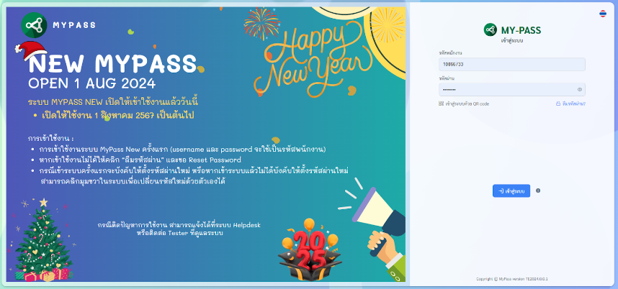
Mypass

Design planning
CMS_Group4_MYP.pdf

User diagram
User_diagram_Group4_MYP.pdf

Windows & Page
- Front_Page ()
Login() :

Register() :

Report() :

- Main_Page ()
User_Data() :

User_Contact_list() :

Approve() :

User_Helpdesk() :

Admin_Data() :

Admin_Helpdesk() :

Logout() :

Position | User_Data() | User_Contact_list() | Request() | Approve() | Admin_Contact_list() | Helpdesk()
Support | / |  | / | / | / | /
Board | / | / | / | /
Human resources | / |  | / | / | /
Manager | / | / | / | /
Worker | / | / | /

